RA-XF500A-WS

QR500 Coaxial Cable

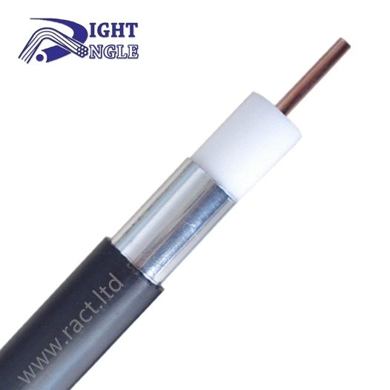

**Product overview**

QR500 cable aluminum tube cable refers to the physically foamed coaxial argon arc welding aluminum tube cable produced in the standard GY/T135-1998, which is widely used in satellite and television cables, including cable television, digital television, closed-circuit television, video transmission, security system and satellite television. Trunk cable, branch distribution cable.

**Construction**

|  |  |  |
| --- | --- | --- |
| Inner conductor | Material | CCA |
| Diameter | 2.77 mm ± 0.02 mm |
| Insulation | Material | FPE |
| Diameter | 11.43 mm ± 0.2 mm |
| Outer conductor | Material | SEAT |
| Diameter | 12.70 mm ± 0.02 mm |
| Jacket | Material | PE |
| Diameter | 14.20 mm ± 0.3 mm |

**Packing**

|  |  |
| --- | --- |
| Package length | 350m / 500m / 750m |
| Customized |
| Box type | Wooden drum |
| Customized |

**Test Data**

|  |  |
| --- | --- |
| Dielectric Strength | Not breakdown with 2kV DC for 1 min |
| Sheath Strength | Not breakdown with 3kV |
| Characteristic Resistance | 75 Ω ± 5 Ω |
| Insulation Resistance | 5000MΩ/km |
| Single Bending Radius | 70 mm |
| Repeated Bending Radius | 125 mm |
| Low Temperature Bending | Not cracked |
| Thermal Shock | Not cracked |
| Inner Conductor Resistance | ≤1.48 Ω/km |
| Velocity | 88 % |

**Certifications and Standards**

|  |  |
| --- | --- |
| Certification | CPR Eca |
| Executive Standards | GY/T135-1998 |

**Technical Test [Attenuation @68°F(20°C)]**

|  |  |  |
| --- | --- | --- |
| Frequency(MHZ) | Maximum(dB/100ft) | Maximum(dB/100m) |
| 5 | 0.16 | 0.52 |
| 55 | 0.55 | 1.80 |
| 250 | 1.20 | 3.94 |
| 300 | 1.31 | 4.30 |
| 350 | 1.43 | 4.69 |
| 400 | 1.53 | 5.02 |
| 450 | 1.63 | 5.35 |
| 500 | 1.73 | 5.67 |
| 550 | 1.82 | 5.97 |
| 600 | 1.92 | 6.30 |
| 750 | 2.17 | 7.12 |
| 870 | 2.34 | 7.69 |
| 1000 | 2.53 | 8.30 |